Interplay between local protein interactions and water bridging
of a proton antenna carboxylate cluster

Ana-Nicoleta Bondar^{1,2,3*,§}

¹University of Bucharest, Faculty of Physics, Str. Atomiştilor 405, Bucharest-Măgurele 077125, Romania
²Forschungszentrum Jülich, Institute for Neuroscience and Medicine and Institute for Advanced Simulations (IAS-5/INM-9), Computational Biomedicine, 52425 Jülich, Germany
³Freie Universität Berlin, Department of Physics,
Theoretical Molecular Biophysics Group, Arnimallee 14, D-14195 Berlin, Germany

*Correspondence to: nbondar@fizica.unibuc.ro

§Current address: University of Bucharest, Faculty of Physics Str. Atomiştilor 405, Bucharest-Măgurele 077125, Romania, and Forschungszentrum Jülich, Institute for Neuroscience and Medicine and Institute for Advanced Simulations (IAS-5/INM-9), Computational Biomedicine, 52425 Jülich, Germany

Abstract
Proteins that bind protons at cell membrane interfaces often expose to the bulk clusters of carboxylate and histidine sidechains that capture protons transiently and, in proton transporters, deliver protons to an internal site. The protonation-coupled dynamics of bulk-exposed carboxylate clusters, also known as proton antennas, is poorly described. An essential open question is how water-mediated bridges between sidechains of the cluster respond to protonation change and facilitate transient proton storage. To address this question, here I studied the protonation-coupled dynamics at the proton-binding antenna of PsbO, a small extrinsinc subunit of the photosystem II complex, with atomistic molecular dynamics simulations and systematic graph-based analyses of dynamic protein and protein-water hydrogen-bond networks. The protonation of specific carboxylate groups is found to impact the dynamics of their local protein-water hydrogen-bond clusters. Regardless of the protonation state considered for PsbO, carboxylate pairs that can sample direct hydrogen bonding, or bridge via short hydrogen-bonded water chains, anchor to nearby basic or polar protein sidechains. As a result, carboxylic sidechains of the hypothesized antenna cluster are part of dynamic hydrogen bond networks that may rearrange rapidly when the protonation changes.

Introduction
Protein proton-collecting antennas are clusters of closely spaced carboxylic, or carboxylic and histidine sidechains, which may collectively capture protons from the bulk, retain protons on the surface of a protein, and transfer protons to or from an internal protein site. Proteins for which proton antennas have been discussed include the reaction centre and cytochrome c oxidase [1], the bacteriorhodopsin proton pump [2, 3], and the PsbO subunit of the photosystem II complex [4, 5]. The size of carboxylate clusters proposed to function as proton antennas can vary greatly, from a couple of carboxylate sidechains in the case of bacteriorhodopsin [2], to as many as twelve-sixteen carboxylates in PsbO [4], and to significant areas of the bacterial reaction center and cytochrome c oxidase [1]. The phospholipid membrane surface may also participate in protonation dynamics [6-9], being thought that the proton antenna functionality of the lipid membrane could accelerate the uptake of protons by the membrane-embedded transporters [7] and act ‘as a proton-conducting link between membrane spanning proton transporters’ [10]. In the purple membrane that hosts the bacteriorhodopsin proton pump, protons released by the pump dwell on the membrane surface, which allows them to travel longer distances [11]. Description of the interactions that govern the dynamics of a bulk-exposed proton antenna cluster, and how these dynamics couple to protonation, is important, because it can provide insights into the general mechanisms used by membrane-bound proteins to capture and release protons from and to the bulk. To study the protonation-coupled dynamics of a bulk-exposed proton antenna, here I report simulations and graph-based analyses of the carboxylic cluster of PsbO, a soluble protein subunit of photosystem II thought to function as proton antenna [4] and to enable local buffering that avoids transient acidification of the thylakoid lumen [5].
PsbO is an excellent model system to study bulk-exposed proton antenna clusters of proteins, because it is relatively small soluble protein with a rigid β-barrel domain (Figure 1). Acid-base titration and spectroscopic measurements of isolated PsbO indicated protein structural change at low pH of 2.8 [12], and two distinct protein conformations being populated at pH 3.4-4.8 vs. 6.0-9.5 [13]. Fourier Transform Infrared (FTIR) spectra of the S1-to-S2 transitions of photosystem II reconstituted with PsbO with vs. without ¹³C isotopic labeling were interpreted to suggest that, during the water-splitting cycle of photosystem II, a reaction during which PsbO looses one or more protons likely involves two carboxylic groups [14].
Three-dimensional structures of the photosystem II complex made it possible to identify protein sidechains that could be involved in proton storage and/or proton transfers from the catalytic center to the lumen bulk (see, e.g., refs. [15-22]), and guided the interpretation of biochemistry experiments to identify carboxylate groups that are likely candidates for the PsbO antenna cluster [4]. Some of the carboxylic groups of the PsbO antenna cluster [4] are close to each other in sequence, such as E180 and E181, D222, D223 and D224, and E97 and D102 (Figure 1).
D158 and D224 of the PsbO proton antenna cluster (Figure 1) appear particularly important for the functioning of photosystem II. Spinach photosystem II complexes in which PsbO-D157 was mutated to Asn, Glu, or Lys, could bind PsbO, but had decreased oxygen evolution activity [23] and altered kinetics [24]; in isolated T. vulcanus thylakoid membranes, PsbO D158E, D158N, and D158K mutants showed defective assembly of soluble subunits [25]. A role of D158 in the assembly of photosystem II, as suggested by the latter experiments, is consistent with previous molecular dynamics (MD) simulations indicating that R162, a group essential for the binding of PsbO to photosystem II [26], has largely perturbed interactions in D158A [27]. PsbO D224, which is located close to D158 (Figure 1), is part of a putative proton-transfer path from the catalytic center to the bulk lumen [15, 16, 21, 28, 29]; MD simulations of the PsbO D224A mutant had altered interactions of R152 [27], a group essential for the binding of PsbO to photosystem II [26]. Relatively close to the D224 site there is another carboxylate of interest, D102 (Figure 1): experiments and computations on a simplified PsbO construct consisting of the β-barrel region without the flexible loops suggested that D102 might be protonated [5, 30].
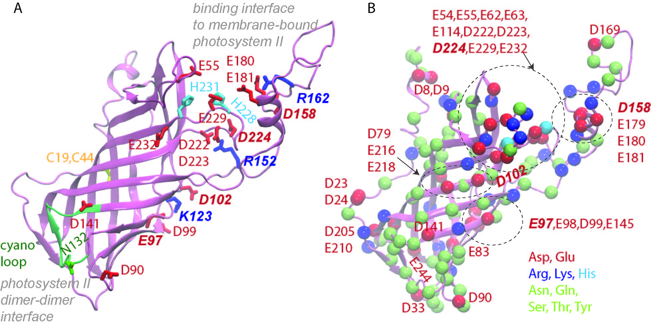
Figure 1. Architecture of T. vulcanus PsbO. (A) Molecular graphics of PsbO illustrating the β-barrel domain, the cyano loop, and selected protein sidechains. Selected sidechains are shown as bonds colored red for Asp/Glu, blue –Arg/Lys, cyan-His, and green-Asn. The disulfide-bridged C19 and C44 are colored yellow. For clarity, H atoms are not shown. The cyan loop is located at the photosystem II dimer-dimer interface; in the photosystem II monomer, R152 interacts with groups of another subunit [21]. (B) Location of polar and charged protein groups on the surface of PsbO. Cα atoms of Asp and Gl are shown as van der Waals spheres colored red, Arg and Lys, blue, His, cyan, and Asn, Gln, Ser, Thr, and Tyr, lime. The dotted lines delineate local carboxylate clusters. K123, R152 and R162, and carboxylic sidechains whose protonation state was considered here, are also labeled with italic fonts. The molecular graphics is based on a coordinate snapshot from simulations of PsbO with standard protonations for all titratable protein sidechains. All molecular graphics were generated using Visual Molecular Dynamics, VMD [31].

Carboxylic and His groups are typically assigned to a proton-binding antenna cluster based on distances from static protein structures, which provide only limited information about the dynamical reorientations of the cluster’s sidechains in a fluid environment. Moreover, for a number of membrane-bound protein systems the carboxylic groups of the antenna cluster neighbor basic sidechains that could influence the dynamics of the carboxylic groups. For example, the cytoplasmic proton-binding cluster of bacteriorhodopsin contains four carboxylic groups that neighbor two basic sidechains [3, 11, 32]. The proton collecting clusters of the bacterial reaction center and of cytochrome c oxidase contain numerous carboxylic and His sidechains, being thought that, at least in the case of the reaction center, two of the His sidechains are required for connectivity within the proton collecting cluster [1]; in cytochrome c oxidase, protons are thought to first bind preferentially to the carboxylic groups, and then transfer to the His groups [33]. The plasma membrane proton pump AHA2 has two conserved Asp sidechains at the proton release site [34] –these are also part of a highly polar region with multiple carboxylic, basic, and polar (non-charged) sidechains [35]. The proton antenna of the green fluorescent protein, which consists of carboxylic and threonine groups, and water, connects to a His and an Asn sidechain [36].
In the case of PsbO, D102 of the proton antenna cluster is conserved as a motif together with E97 and K123 (Figure 1A) [27], and quantum mechanical computations of model systems suggested that local H-bonding of K123 may impact the energetics of proton transfer from D102 to E97, as reduced flexibility of K123 associated with somewhat higher proton-transfer barrier [37]. At the region where PsbO binds to photosystem II, the conserved R152 and R162 are close to D224 and D158, respectively (Figure 1A). Mutating either Arg sidechain to Gly (R151 and R161 in spinach PsbO numbering) reduces binding of PsbO to the photosystem II complex, and is detrimental to oxygen evolution [26].
Taken together, the considerations above suggest that the local interactions with basic and polar sidechains might be a rather general feature of proton-binding proteins. Although a role for basic sidechains for the connectivity between carboxylic groups of the antenna cluster has been proposed [1], the dynamics of the interactions between basic and carboxylic groups of an antenna, and whether these interactions couple to protonation change, remains unclear. These aspects are studied here using atomistic molecular dynamics (MD) simulations and graph-based analyses of the dynamic H-bond networks of the carboxylic cluster of PsbO.
Eight independent MD simulations were carried out, distinguished by the protonation of four carboxylic groups –E97, D102, D158, and D224 (Figure 1), as these Asp and Glu sidechains are of direct interest to proton binding. Nuclear Magnetic Resonance (NMR) measurements of pK_{a} values and high-resolution X-ray crystallography of a truncated PsbO variant indicated D102 is likely protonated [5, 30], with a pK_{a} >7 [5]. Protonation of D102, or of the nearby E97, is compatible with the 2.8Å distance between these residues in a high-resolution structure of the photosystem II complex [28]; for E98, the NMR measurements on truncated PsbO found a pKa of ~5 [5]. D158 and D224 are part of the proton antenna cluster proposed for PsbO [4], and part of the proton-exit pathway hypothesized for photosystem II [15]; for D224, earlier pK_{a} computations indeed indicated values as large as ~9, whereas D158 was found to have a very low pK_{a} value [16].
The graph analyses of the protein-water H-bond networks of PsbO indicate that dynamic, transient water bridges can give rise to extensive protein-water H-bond networks. Persistent connectivity between carboxylate groups tends to be somewhat local, such that relatively frequent connections tend establish clusters of just a couple of carboxylate groups. Almost all such local carboxylate clusters involve positively charged or other polar sidechains that mediate connectivity via frequent interactions with carboxylate groups. Protonation of a carboxylate sidechain tends to associate with rearrangements of its local H-bond cluster.

Materials and Methods
Protein structure and simulation systems. Coordinates for PsbO were taken from the crystal structure of photosystem II, PDB ID: 3ARC, chain O [20]. From the crystal structure, the coordinates of PsbO, the calcium ion bound to PsbO, and for 195 water molecules, were used. C19 and C44 were disulfide bridged [38]. The protein was placed in a box of water molecules, and bulk water molecules overlapping with the protein and crystal structure waters were deleted. Sodium ions were added for charge neutrality. The resulting simulation system includes ~181.060 atoms.
The independent simulations reported here are distinguished by the protonation of specific carboxylate sidechains, as follows. In the reference simulation, all titratable groups were assigned standard protonation states, i.e., all Asp/Glu sidechains were negatively charged, Arg/Lys sidechains, positively charged, and His sidechains neutral with Nε2 protonated. This reference simulation was started from the same coordinates as used before for PsbO [27, 29] but with new initial assignment of atom velocities. Six simulations have protonated (neutral) E97, D102, D158; for each of these four carboxylate sidechains, two independent simulations were performed, distinguished by the carboxylate oxygen atom that is protonated. An additional simulation was performed with D224 protonated.

Force field and protocol for MD simulations. The CHARMM36 force field [39-41] with the CMAP correction, and the TIP3P water model [42], were used for all computations. Coulomb interactions were computed using the smooth particle mesh Ewald summation [43, 44]; for short-range interactions in real space, a switch function between 8Å and 12Å was used. Covalent bonds involving H atoms were constrained [45]. MD simulations were performed with NAMD [46, 47]. Geometry optimization was followed by heating to 300K and 1ns of equilibration in the NPT ensemble (constant number of atoms N, constant pressure P = 1 bar, and constant temperature T = 300K), in a Langevin dynamics scheme [48, 49] with anisotropic pressure coupling; all production runs were performed with isotropic pressure coupling. During heating and first 1ns of equilibration the integration step was 1ns; during the remaining of the simulations, a multiple time step integration scheme was used with 1fs for the bonded forced, 2fs for short-range nonbonded, and 4fs for long-range electrostatics [50]. Coordinates were saved each 10ps.

H-bonds, H-bond occupancy, water-mediated bridges, H-bond clusters, and shortest-distance paths. Two groups are H bonded when the distance between donor and acceptor heavy atoms is ≤3.5 Å, and the H-bond angle is ≤ 60º. That is, H-bonds between polar sidechains are computed together with salt-bridges. For simplicity, direct and water-mediated H-bonds are computed only for sidechains.
The occupancy of an H-bond is given by the percentage of coordinate sets, from the trajectory segment used for analyses, during which the H-bond criteria are met.
A water bridge between two protein sidechains is a chain of H-bonded water molecules that bridges the two groups. For clarity, and since longer water bridges tend to be short lived [29, 37], H-bond graphs were computed for one-water bridges between protein sidechains, and separately for one- and two-water bridges.
An H-bond cluster, or local H-bond network, consists of a subset of nodes and edges that are inter-connected to each other. The shortest-distance path between two nodes of the graph (two H-bonding groups) is the path that connects those two nodes via the least number of edges (H-bonds). The H-bond cluster of specific amino acid residues, and shortest-distance paths between pairs of sidechains of interest, were extracted from the H-bond graphs using the Connected Component Analysis tool of Bridge [51, 52]. All H-bond graph computations were performed with Bridge2 [51, 52] using 11200 equally spaced coordinate sets from each simulation. Average numbers of water molecules that bridge selected protein sidechains were extracted from the Bridge H-bond graph computations.

Results and Discussion
Motions of PsbO were probed for different protonations of four carboxylate groups. Taken together, the simulations performed amount to ~1.4μs. During all MD simulations performed the structure of PsbO remained stable, with overall comparable numbers of protein sidechain H-bonds (Table S1) and one-water bridges between protein sidechains (Table S2).
Proton transfer in acid-base reactions has maximum probability when the number of intervening waters between acid and base is 2-3 [53]. To dissect the role of protein vs. water-mediated bridges between carboxylate groups, and to explore the spatial extent of connectivity within the carboxylate clusters, each simulation was subjected to four H-bond graph computations: i) direct H-bonds between sidechains; ii) one-water mediated bridges between sidechains; iii) one- and two-water-mediated bridges between sidechains; iv) direct H-bonds, one, and two-water mediated bridges separate H-bond graph computations were performed for the both direct sidechain H-bonds, and one- and two-water mediated bridges.
Analysis of graphs of water-mediated bridges with one vs. two water molecules provides clues about the relative distances and dynamics of the two sidechains bridged by H-bonded water(s); H-bond graphs computed for direct H-bonds between sidechains, as compared to graphs for water-mediated H-bonds, illustrate connectivity of the H-bond network established via fluctuations of water molecules and protein sidechains. The H-bond graphs computed from the eight simulations are presented in Figures S1-S29, and summarized in Tables S1, S2.

Occupancy thresholds for H-bond graphs. A Bridge H-bond graph computation reports all H-bonds regardless of their occupancy. Given the large number of direct and water-mediated H-bonds sampled at least transiently during a simulation, its is impractical to analyze all H-bonds sampled at least once during any of the nine simulations performed. Thus, it is of interest to consider an occupancy threshold, i.e., to simplify the H-bond graphs such that only H-bonds that are sampled relatively frequently will be displayed. The precise value of the minimum occupancy threshold is, however, unclear. Consequently, to test how the H-bond occupancy used impacts the H-bond graphs, relatively low occupancy thresholds of 20-30% were first considered.
The H-bond graph computed for direct protein sidechains using the reference simulation with standard protonation of all titratable sidechains contains 32 H-bonds when shown at an H-bond occupancy ≥30% (Figure S1). Of these H-bonds, about half have occupancies ≥50%, and a few are sampled throughout the entire trajectory segment used for analyses (Figure S1, Table S1).
The number of sidechain-sidechain H-bonds with occupancies ≥30% in the simulations reported here is somewhat high: Table S1, which summarizes the H-bonds sampled with occupancies ≥30%, contains >70 unique H-bonds. In pairs of simulations performed with the same carboxylate protonated, H-bonds that are present in both simulations tend to have occupancies ≥50%, but some of these H-bonds have occupancies of ~30-40% (see e.g., the D79-Q80 H-bond in simulations with protonated D102 protonated, and the D23-T25 H-bond in simulations with protonated E97 or with protonated D158, Table S1). A minimum occupancy threshold of 30% thus appears reasonable for analyses of the graphs of sidechain-sidechain H-bonds.
To find the occupancy threshold for water-mediated H-bond networks, the H-bond graphs computed for one- and two-water mediated bridges were inspected separately. Overall, short bridges with just one water molecule between two protein sidechains tend to have occupancies below 50% (Table S2, Figures S1B, S6, S9, S15, S17, S21, S26, S28). The only one-water bridge common to all H-bond graphs shown at occupancies ≥20% is that between E145 and K194 (Table S2).
The graphs of one- and two-water mediated H-bonds with occupancies ≥20% have networks that extend across a large part of the protein, but many of the water bridges have relatively low occupancies (Figures S2, S7, S16, S18, S22, S27, S29). Given the large number of transient water bridges, in order to facilitate comparisons of the protein-water H-bond networks with one- and two-water bridges, the graphs were first analyzed at occupancies ≥50%; where necessary, protein-water H-bond graphs computed at occupancies ≥20% were used to evaluate less frequent connections that could be of interest for specific carboxylate clusters.

Protonation-dependent protein interactions of carboxylate sidechains. The four direct interactions between sidechains that are sampled in all simulations with occupancies of at least 30% are at the β-barrel domain of PsbO (see D24-K203, R42-D79, and R39-E98 and K53-E232 in Figure 2 and Table S1). As summarized below, for a number of interactions in H-bond clusters that involve Asp/Glu groups, dynamics can depend on the protonation used for specific Asp/Glu sidechains.
In the reference simulation with all Asp/Glu negatively charged, a network of 15 sidechain H-bonds extends from E55/E229 to D158, E180/E181, and D222/D224, such that it includes seven Asp/Glu sidechains (Figure 2). Within this cluster, 12 H-bonds have occupancies ≥30%, including two persistent H-bonds at the E97/D102 site (see K123 and Y151 in Figure 2B).
Local H-bond clusters in which E55 and E229 connect via K57 or R60 are sampled when D102 or D224 are protonated (Figures 3A, 3C, 4, S4A, S4B), and in one of the protonated E97 simulations (Figures 3D, S12); when D158 is protonated, E55 connects to K57, but E229 either has one weak connection to H231, or is part of an H-bond cluster with E180/E181. That is, when D158 is protonated, at the H-bond occupancy threshold used the extended E55-E229-D158-E180-D224 H-bond cluster identified in the reference simulation (Figure 2B) separates into the local H-bond of E55, and an E180-E229 H-bond cluster (Figure 3B).
E97 connects directly to K123, and D158 to R162, in all simulations except when E97 and, respectively, D158, is protonated (Figures 2, 3D, S23, Table S1). When D102 is protonated, K123 interacts with both E97 and D99; in one the protonated D102 simulations, D102 bridges to D99 (Figure 3A, Table S1, Figure S4A). D102 connects to K123 when E97 is protonated (Figures 2, 3D, Table S1).
D158 and D224 tend to be part of a common H-bond cluster when negatively charged (Figures 2,3), but not when protonated: Protonated D158 makes infrequent connection with T153 or is absent from the H-bond graph (Figures 4B, S12); likewise, protonated D224 makes infrequent connections with R152, or it is part of a small cluster with R152 and D222 (Figures 3C, S19A).
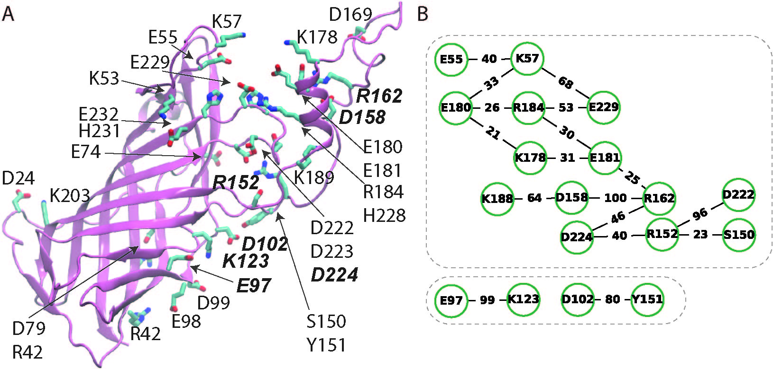
Figure 2. Direct protein H-bonds in PsbO with standard protonation. (A) Molecular graphics of PsbO showing selected protein sidechains that can H-bond to another sidechain. Selected basic and carboxylic sidechains discussed in the text are labeled with italic bold bonds. (B) Clusters of sidechain-sidechain H-bond extracted with Connected Components Analyses [51, 52] from the H-bond graphs. To illustrate long-distance transient connections between the E55-E229 and D158-D224 H-bond clusters, the minimum occupancy threshold was lowered to 20%. The corresponding graph of protein sidechain H-bonds with occupancies ≥30% is presented in Figure S1A.

In summary, the local H-bond clusters discussed above have similar numbers of Asp/Glu vs. basic and polar sidechains in independent simulations. Some H-bonding sidechains contribute to H-bond clusters in all, or most of the simulations performed (Figure 4). Thus, at the H-bond occupancy threshold used, of the E55-E229 cluster sampled in the reference simulation, only E55 and E57 remain in the H-bond clusters of most simulations performed with a protonated Asp/Glu sidechain (Figure 4). Unless protonated, E97 H-bonds to K123, and D102 is part of an H-bond cluster with E97 and K123 in most simulations performed. Unless protonated, D158 is part of an H-bond cluster with R152 or R162; likewise, unless protonated, D224 is part of an H-bond cluster with R152 or R162 (and with negatively-charged D158) (Figure 4). These H-bonding sidechains that are common to the local H-bond clusters appear to recruit other nearby groups, including polar sidechains, giving rise to larger local H-bond clusters.
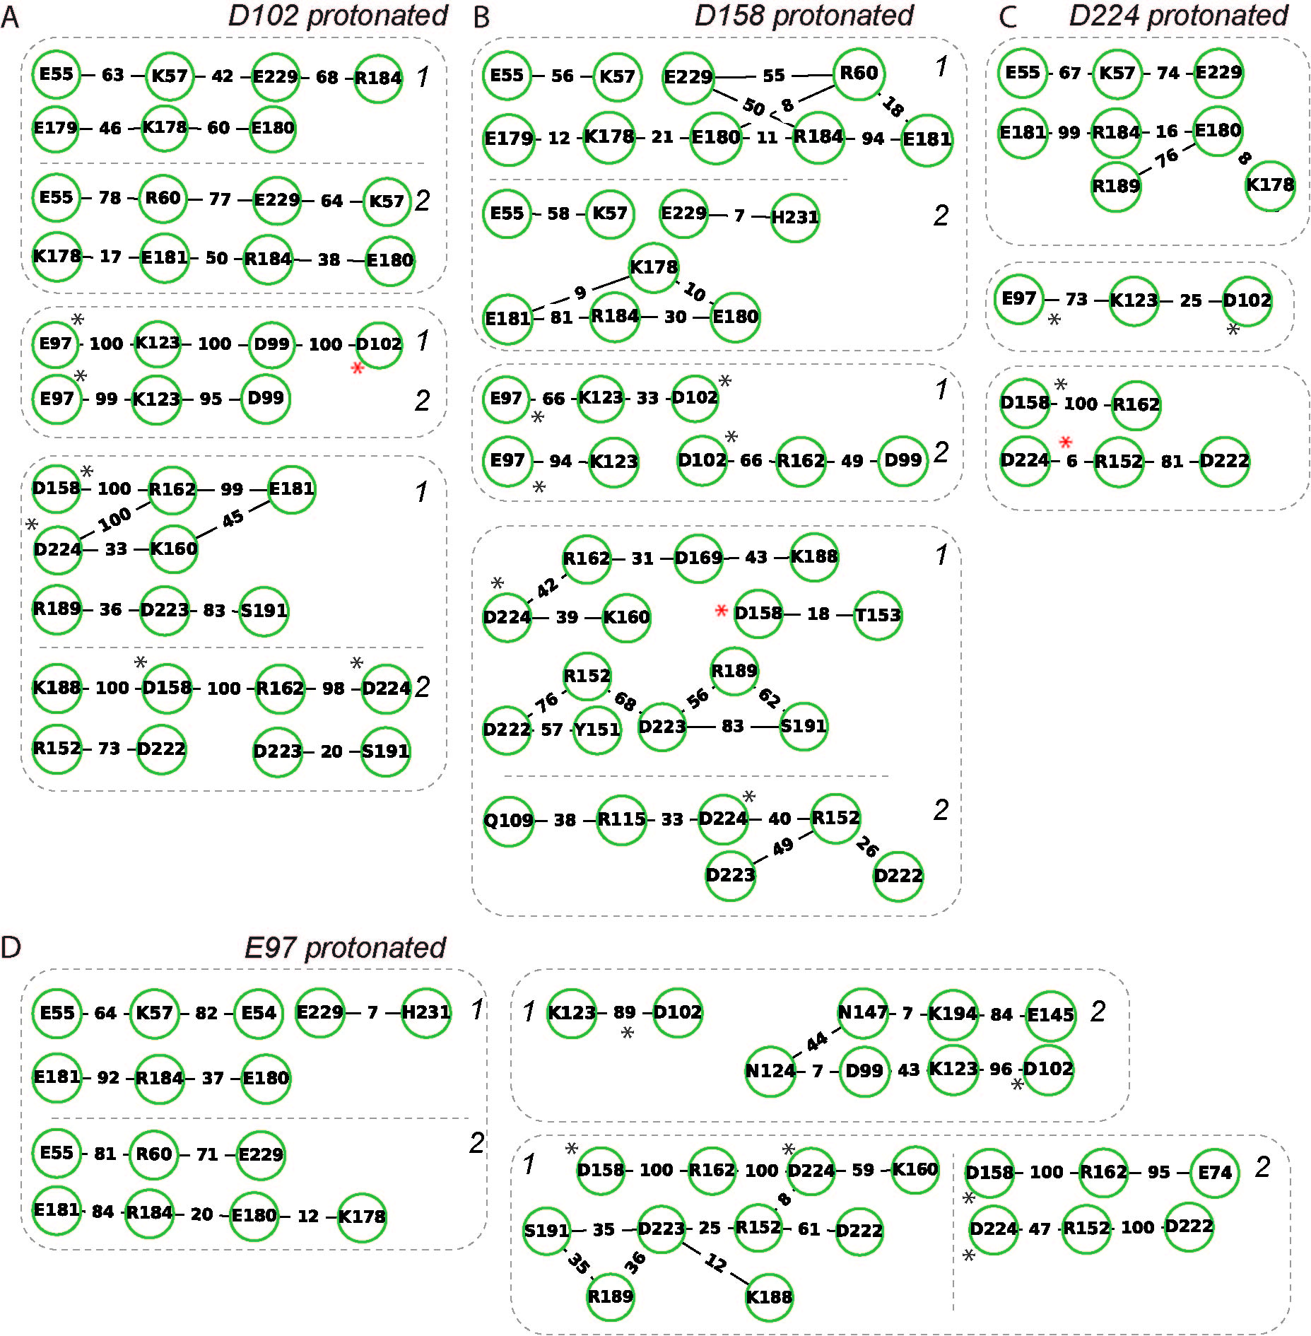
Figure 3. Protein H-bond clusters in PsbO with one Asp/Glu protonated. When applicable, the italic numbers 1 and 2 indicate independent simulations performed with one Asp/Glu protonated. An Asp marked with a red star is protonated; Asp/Glu marked with a gray star are protonated in another simulation. (A-D) H-bond clusters of PsbO with protonated D102 (panel A), protonated D158 (panel B), protonated D224 (panel C), and protonated E97 (panel D). Note that protonated D102 may H-bond to D99, and protonated E97 lacks direct H-bonds with another protein sidechain. Graphs for direct sidechain H-bonds with occupancies ≥30% are presented in Figures S4, S12, S19A, and S23.

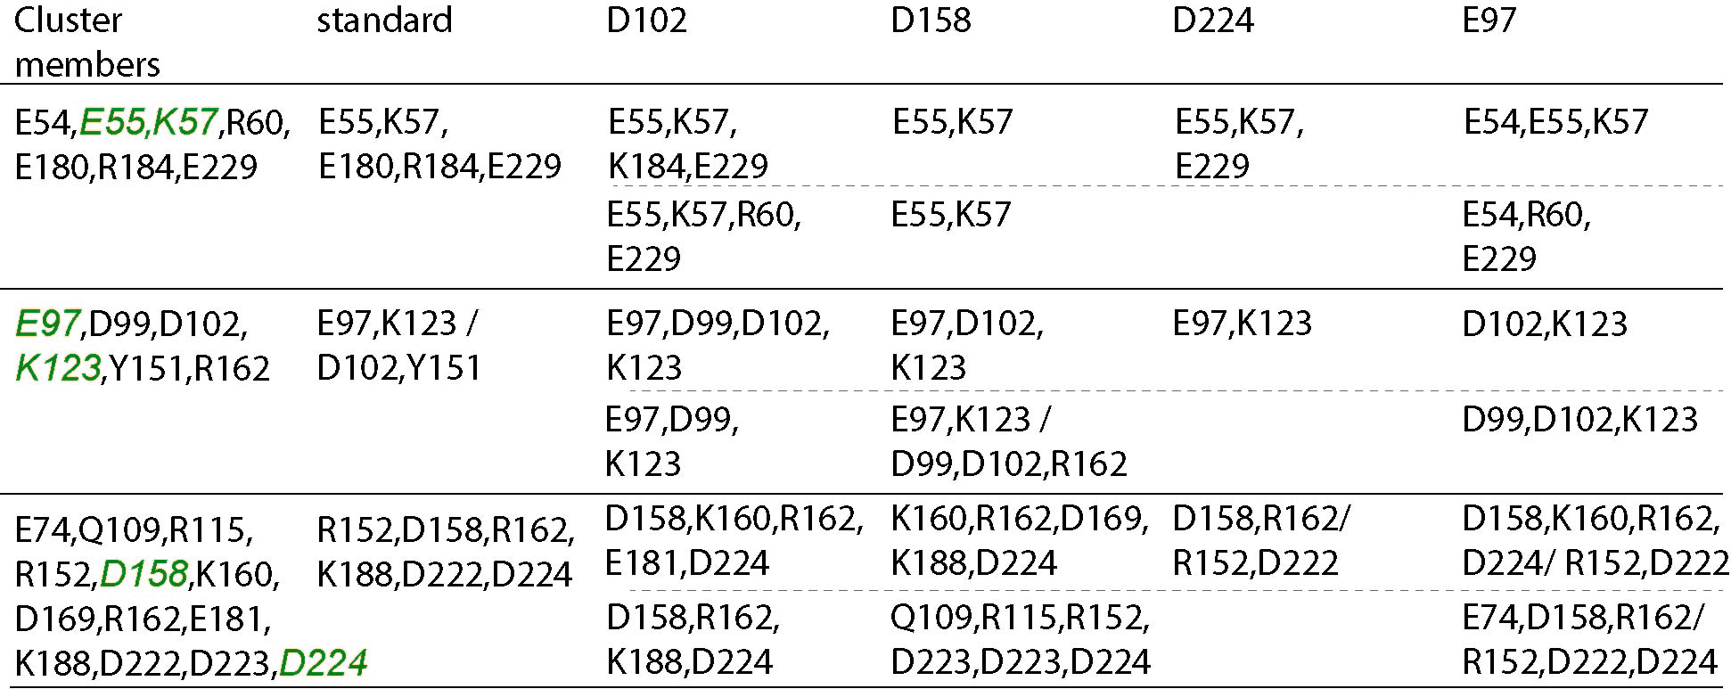
Figure 4. Summary of the composition of the selected protein H-bond clusters computed with a minimum H-bond occupancy of 30%. ‘Cluster members’ indicates all sidechains that may contribute to the cluster in any of the simulations performed. Amino acid residues labeled with green italics are present in H-bond clusters of most simulations performed. ‘Standard’ indicates PsbO with standard protonation of all titratable sidechains. ‘D102’, ‘D158’, ‘D224’, and ‘E97’ indicate the Asp/Glu sidechain considered protonated. The dotted lines separate the H-bond clusters in independent simulations performed for PsbO with a protonated Asp/Glu; when present, the ‘/’ indicates two local H-bonds or H-bond clusters without a direct connection in the graph. The H-bond graphs from which the summary was extracted are presented in Figures S1A, S4, S12, S19A, and S23.

One-water carboxylate bridges anchor to basic or polar protein sidechains. One-water mediated bridges between Asp/Glu sidechains tend to be sampled when at least one of the Asp/Glu also bridges to a polar or basic sidechain; moreover, as illustrated in Figures 5A-D for the E55 cluster, protein sidechains inter-connected by one-water bridges (Figures 3A,B) tend to also sample direct H-bonding (Figures 2, 3B, 4). Examples of sites where 2-3 carboxylates bridge to each other via one water molecule and also anchor to polar/basic sidechains include E55-E229 (Figures 4, 5, S1B), and D158-D224 (Figures 4, S1B, S6, S12, S13). One-water-mediated bridges between E97 and D102 are sampled in one of the protonated D102 simulations (Figure S6), and bridges between D8 and D102, in one of the protonated E97 simulations (Figure S26).
Figure 5. Protein and water interactions at selected regions on the surface of PsbO. (A) Close view of protein sidechains of the E55 protein-water H-bond cluster in PsbO with standard protonation. (B) E55 H-bond network computed for one-water bridges between protein sidechains, shown at a minimum H-bond occupancy of 20%. Graph nodes (amino acid residue sidechains) that are also present in the protein H-bond network shown in Figure 2B are colored green; other nodes of the protein-water network are colored dark yellow. (C) The E55 H-bond cluster with one- and two-water bridges between protein sidechains. (D) The E55 H-bond cluster with one- and two-water bridges between protein sidechains, and with direct H-bonds between sidechains. For each edge that connects two nodes of the graph, numbers in italics give the average number of waters that bridge the two sidechains. For clarity, given the large number of two-water bridges, H-bond graphs in panels B and C are shown at a minimum H-bond occupancy of 50%. (E) Close view of interactions near the E97-D102 site from a simulation with protonated D102. (F) Close view of interactions from the E55-E229 and D158-E224 from simulations with protonated D224. (G) Protein and water interactions in the D158-D224 region from a simulation with protonated D158. For clarity, protein H atoms are not shown, except for the H atom of the protonated Asp/Glu carboxyl. In panels A and G, water molecules displayed as van der Waals spheres have their oxygen atoms within 3.5Å of the sidechain oxygen and nitrogen atoms of the sidechains shown.

Two-water bridges enable extended, dynamic protein-water H-bond networks. When bridges with one or two waters and H-bond occupancies ≥20% are considered, H-bond graphs contain extensive water-mediated bridges that can include a large number of groups, thus extending across a significant region of the protein surface (Figures S2, S7, S10, S16, S18, S22, S27, S29). H-bond graphs for one-and two-water bridges have extensive networks that include the E55 and D158-E180-D224 sites; in a graph computed for PsbO with protonated D158, this network contains >40 protein sidechains (Figure S16). Many of these water-mediated bridges between protein sidechains are only visited transiently such that, when only bridges contributed by H-bonds present ≥50% of the time are considered, the water-mediated clusters tend to be somewhat more localized, though they may still include >7-10 sidechains (see the E55 cluster in Figure 5C, and the summary of water-mediated clusters in Figure 6).
The clusters of water-bridged sidechains can include sidechains that are also part of clusters of direct H-bonds –such as the negatively charged E97 (Figure 6), and typically include polar sidechains.
Protonation of E97, D158 or D224 alters local water bridging: When D158 is protonated, D224 bridges to 3-5 other sidechains, D158 lacks persistent water bridging, and the E55 H-bond clusters are small (Figure 6). Likewise, protonated E97 or protonated D224 lack clusters with persistent water bridging of E97 or D224, respectively (Figure 6). Protonated D102 associates with water-bridged clusters between E97, D102, and N124 (Figure 6).

H-bond networks with protein H-bonds and water bridges anchor to basic and polar sidechains and contain persistent water bridging between carboxylate pairs. H-bond graphs computed for both the protein sidechains and water bridges, together with the graphs discussed above for the sidechains vs. water bridges, can unify the picture of dynamic connections between protein sidechains. As detailed below, when direct sidechain H-bonds are included in graph computations together with water-mediated bridges, a common picture emerges, whereby clusters of three carboxylates bridged via waters have at least one anchor to a basic sidechain, and at least one anchor to a polar sidechain that can donate H-bonds; these anchors may involve sidechains close in sequence to a carboxylate of the cluster.

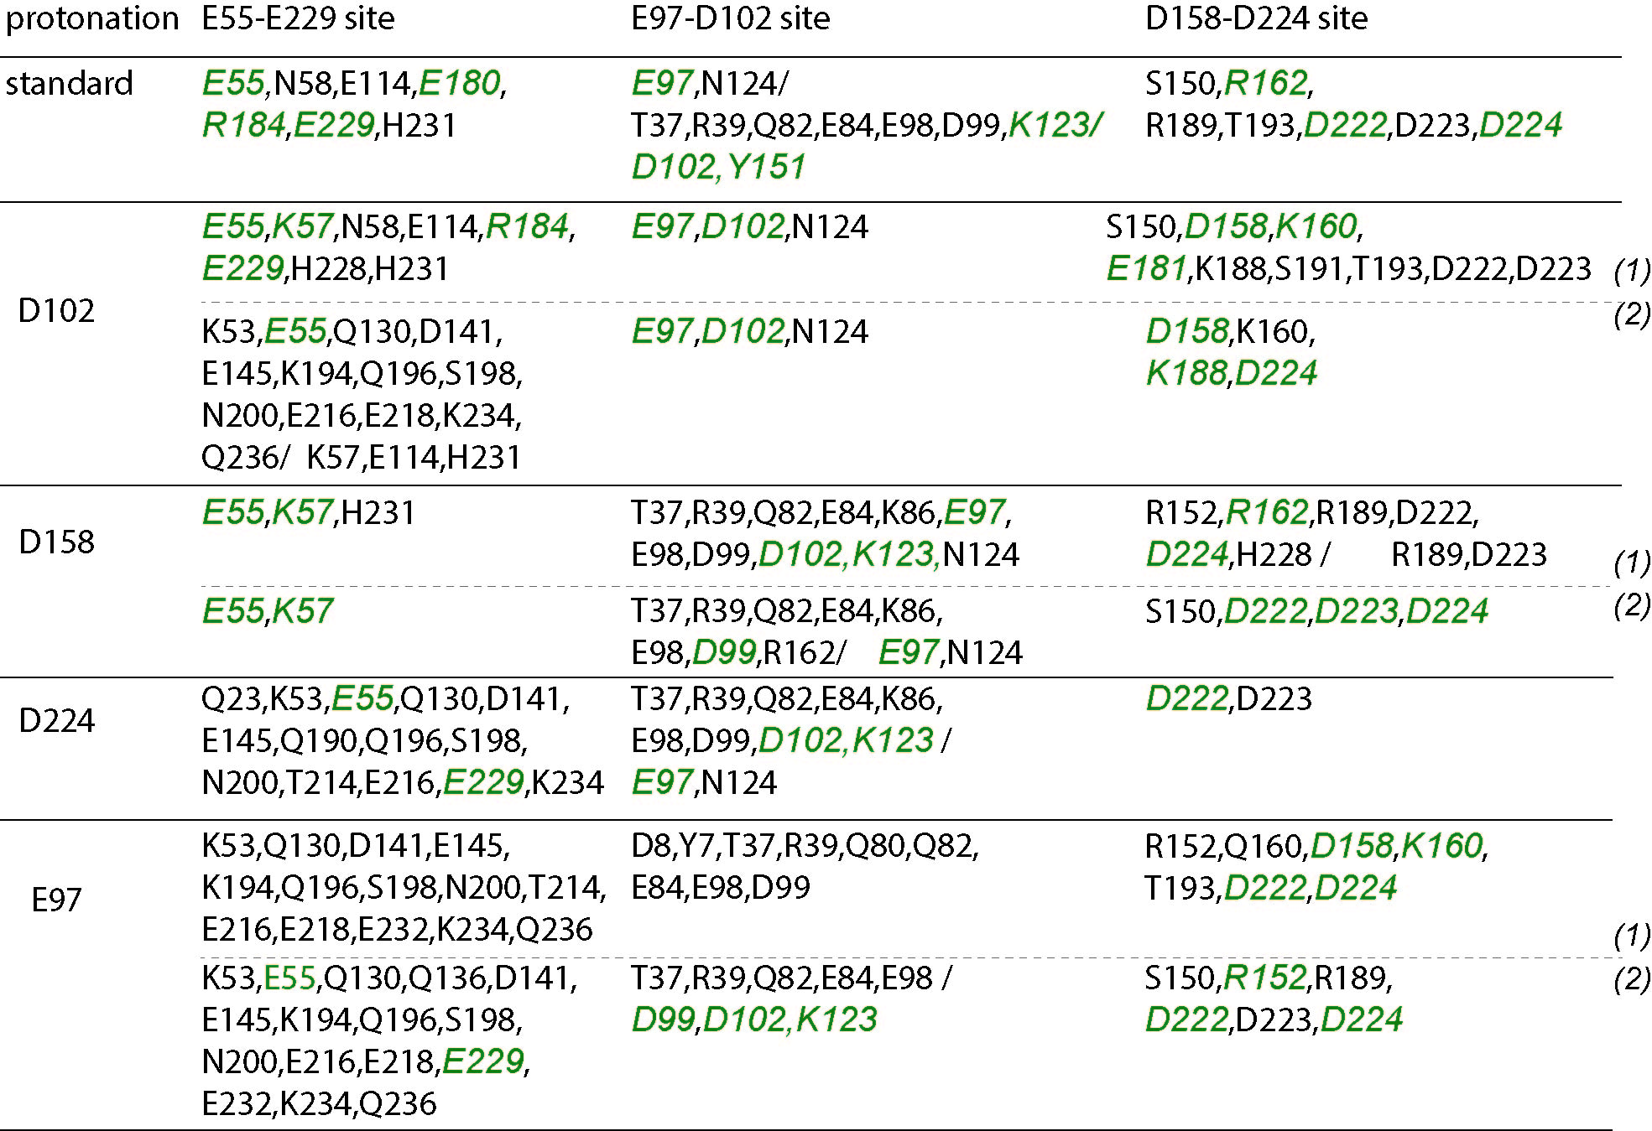
Figure 6. Water-mediated bridges between protein sidechains at selected sites on the surface of PsbO. ‘Protonation’ indicates which of the carboxylate sidechains were considered protonated, or whether a standard protonation was used. H-bond clusters are reported according to their location. Amino acid residues labeled with green italics are also part of local H-bond clusters between sidechains (see Figure 3); the ‘/’ sign indicates groups of amino acid residue sidechains which, at the H-bond occupancy considered, are part of distinct local clusters. Note that, in simulations with D102 protonated, water bridging between E97 and K123 occurs with occupancies of ~26-48% (Figures S7, S10); protonated D158 can bridge to D224 infrequently (~33% occupancy, Figure S16). Where applicable, ‘(1)’ and ‘(2)’ indicate simulations performed with the same protonated Asp/Glu.

Overall, when H-bond graphs are computed at a minimum H-bond occupancy of 50%, basic and polar sidechains dot the local H-bond clusters such that the clusters have relatively similar numbers of Asp/Glu sidechains vs. basic or polar sidechains. For example, in the reference simulation with standard protonations, the E55 H-bond cluster includes 5 Asp/Glu, 3 Arg/Lys, 1 Asn, and 1 His sidechain (Figure S3B), and the E84 cluster has 10 Asp/Glu, 5 Arg/Lys, and 7 Asn/Gln/Ser/Thr sidechains (Figure S3B).
The analyses above of local H-bond networks computed only for protein sidechains, and separately for water-mediated bridges between sidechains, indicated that the dynamics of local H-bond clusters can depend on the protonation of a particular Asp/Glu sidechain. To explore protonation-dependent connections between selected Asp/Glu sidechains on the surface of PsbO, all H-bond graphs computed for both sidechain and water-mediated H-bonds were subjected to Connected Component Analyses in Bridge as follows. First, the composition of the protein and protein-water H-bond clusters of E55-E229, E97-D102, D158, and D224, was inspected manually. Then, shortest-distance paths were computed between any of these Asp/Glu sidechains and other Asp/Glu of the same local cluster. To capture more of the details of specific connections within clusters sampled in simulations with different protonations, the H-bond occupancy was lowered to 20%. As illustrated in Figure 7 and summarized below, the shortest-distance connections found between Asp/Glu pairs can be mediated by water bridges, or they can pass via one ore more basic/ polar sidechains.
Regardless of the protonation used, the shortest distance path between E55 and E220 consists of water-mediated bridges with about 1.4-1.9 waters in the bridge (Figure 7). When either D102 or E97 are protonated, the shortest distance path that connects them is a water-mediated bridge that is sampled more frequently when D102 is protonated, than when E97 is protonated (Figure 7).
Water-mediated bridging between D158 and D224 may be sampled, but somewhat infrequently, and it is disfavored, when either Asp is protonated. When both D158 and D224 are negatively charged, the shortest-distance path that connects them is either a persistent water bridge, or a protein-water H-bond path (Figure 7). The finding that D158 and D224 can bridge via water bridges with ~1.5-2 waters in the bridge, or via protein-water H-bond paths (Figure 7) could explain the coupling between the local dynamics of the D158-D224 H-bond clusters and the protonation of either Asp sidechain.
In summary, for each of Asp/Glu pairs above (E55-E229, E97-D102, and D158-D224) the shortest-distance interconnecting path can be a short water-mediated bridge. The sampling of water-mediated shortest-distance paths between the E97-D102 and D158-D224 pairs appears to depend on protonation. For all three Asp/Glu pairs chosen for investigation, graphs computed for direct protein H-bonds (Figures 2B, 3) indicate anchoring via H-bonding to a basic or polar sidechain: K57 and/or R60 for E55-E229, K123 for E97-D102, and R152, T153, or R162 for D158-D224.

H-bond clusters at the PsbO-PsbO binding interface. In the three-dimensional arrangement of dimers of photosystem II from T. elongatus, two PsbO proteins from adjacent dimers interact with each other via groups of the loop known as the cyano loop [54] (N132 to D141 in T. vulcanus numbering [54, 55]) and N132 is within ~7Å from D90 (Figure 1A). NMR data indicated that amino acid residues near the cyano loop give pH-sensitive amide signals, which could be interpreted to suggest modulation of the dimer contacts [5].
A number of local H-bond clusters involve groups of the cyano loop, but longer distance connections between the cyano loop and more remote protein regions across the β-barrel domain are typically infrequent. Since the structure of the β-barrel domain of PsbO is thought to be largely the same in the isolated protein and in the photosystem II complex, absence of extended couplings via persistent H-bonds suggests that interactions between copies of PsbO proteins in a photosystem II dimer are unlikely to have a major impact on the H-bond dynamics at remote sites.
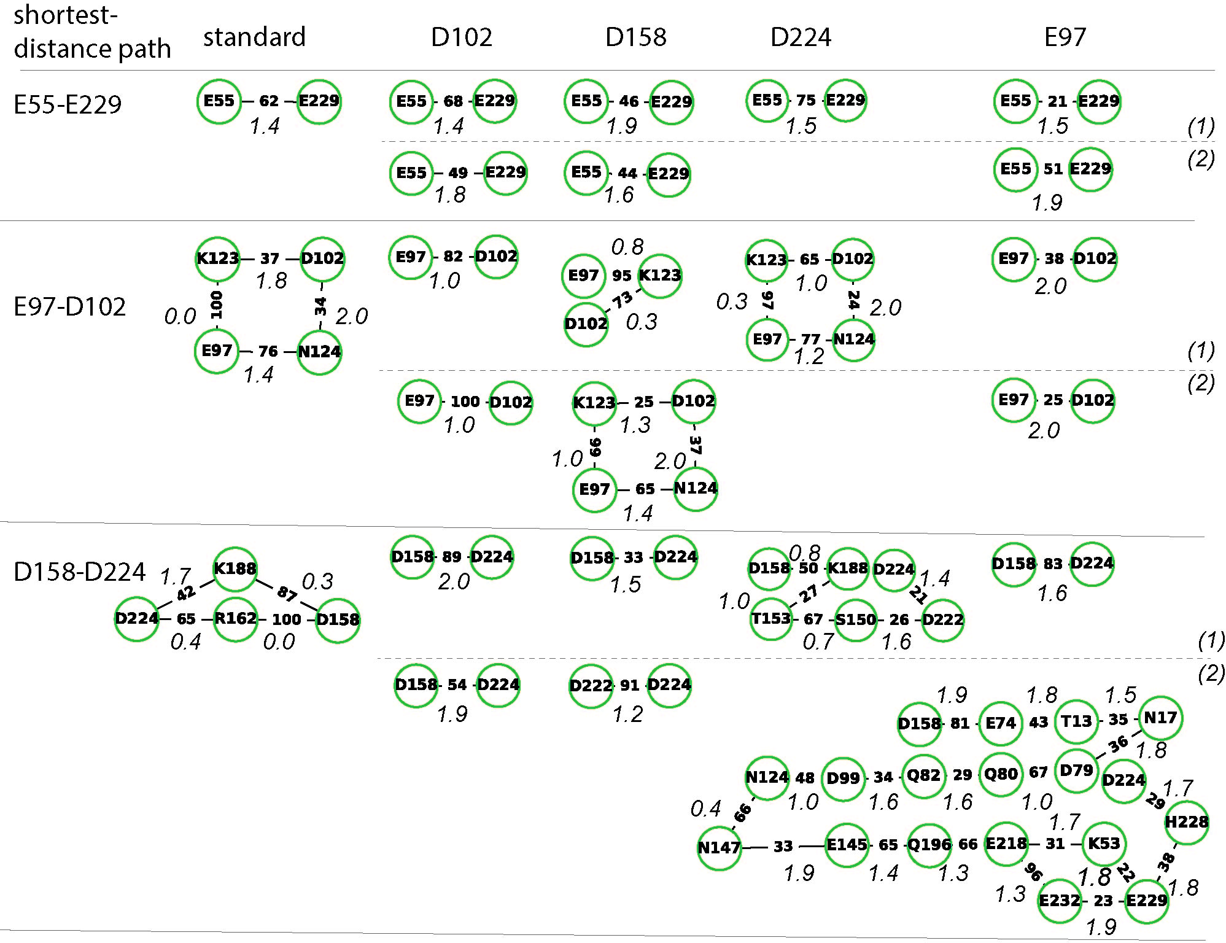
Figure 7. Shortest-distance paths between Asp/Glu sidechains of selected protein-water H-bond clusters. All shortest-distance paths between selected pairs of Asp/Glu sidechains were extracted, using Connected Components Analyses, from the H-bond graphs computed for both the direct H-bonds between protein sidechains, and the one- and two- water-mediated bridges. H-bond occupancies are ≥20%. ‘Shortest-distance path’ indicates the Asp/Glu pair for which the shortest-distance path computation was performed. Note that, since in one of the simulations with protonated D158 no path could be found between D158 and D224, the shortest-distance path between D222 and D224 is shown instead. Numbers along the edges connecting any two nodes indicate the occupancy of the H-bond or of the water bridge between the two nodes; numbers in italics along the edges indicate the average number of the bridging water molecules. When applicable, ‘(1)’ and ‘(2)’ indicate the independent simulations performed with the same Asp/Glu group protonated.

Briefly, one-water bridges include T137, T138, S139, and T140 (Figure S1B). D141 water bridges to N200, and E145 interacts directly with K194 (Figure S1B). An H-bond cluster of N200 with S139, D141 and T214, may be sampled (Figure S2) and extend to Q130/K143 (Figures S1B, S3), and S198 (Figure S5). Near the cyano loop, E210 has frequent direct H-bonds with T208 and Y240 (Figure S1A), there is frequent two-water bridging between E210 and D205, and between Y240 and R42. Close to D205/E210, D8 and D9 connect frequently to each other via two-water bridges, and D33 water-bridges with S35 and Q36 in most graphs with occupancies ≥50% (Figures S3, S8, S11, S14, S20). In Synechocystis sp. PCC6803, mutating PsbO D9 to Lys, or D10 to Arg, His, Asn, or Ser, reduced somewhat the binding of PsbO to photosystem II [56].

Conclusions
Characterizing protonation-coupled dynamics is of general interest to understand proteins whose functioning involves proton binding and proton transfer. During the reaction cycles of these proteins, one or more titratable sidechains change protonation, and the change in the local electrostatic interactions upon protonation change couples with changes in protein dynamics. In the case of membrane-bound proteins that collect and/or transfer protons at a membrane interface, bulk-exposed clusters of carboxylate groups, or of carboxylate and histidine groups, are hypothesized to bind protons transiently. How such carboxylate clusters respond to changes in protonation can be challenging to assess, because numerous H-bonds that may be visited at least transiently at bulk-exposed protein interfaces. To tackle this challenge, here a systematic analysis was pursued based on graph-based analyses of dynamic H-bond networks of a simpler proton-antenna model protein.
The simulations reported here probed the dynamics of PsbO with different protonation states of four carboxylic groups. To dissect the dynamics of H-bond networks, H-bond graphs were computed separately for interactions between protein sidechains, for water-bridges between protein sidechains, and for both sidechain-sidechain H-bonds and water bridges between sidechains. Given the large number of H-bonds that were inspected here, H-bond graphs were analyzed using H-bond occupancy thresholds, which are not unique. An H-bond occupancy threshold of 30% was found useful to compare direct H-bonds from independent simulations, a lower threshold of 20%, to visualize extended, dynamic protein-water H-bond networks, and a stricter threshold of 50%, to simplify comparisons of protein and water-mediated H-bond networks from distinct simulations.
The H-bond graphs analyses suggest that the surface of PsbO hosts extensive protein-water H-bond networks which, when transient two-water bridges are considered, may extend across large numbers of protein sidechains, i.e., across large protein regions. Direct interactions and short water bridges between carboxylate sidechains are of particular interest for considerations of proton binding at surface-exposed carboxylate clusters. The graphs of H-bond networks computed here for PsbO, which included all sidechains that could H-bond indicate that Asp/Glu sidechains that connect via 1-2 water bridges also anchor to nearby basic or polar sidechains. For all four Asp/Glu sidechains whose protonation was considered here, protonation influenced dynamics of their local H-bond clusters.
Although guided by information from previous works, the choice of four carboxylate sidechains whose protonation was considered here could appear as rather limited when considering that the surface of PsbO contains numerous other carboxylate sidechains (Figure 1A), and the protonation of any of these other carboxylate sidechain, or combinations thereof, could be of putative interest. Such a large set of simulations and data analyses would however, be impractical. Moreover, the qualitative picture suggested by the H-bond graphs presented here, whereby anchoring to basic and polar sidechain maintains carboxylates within distance for water-bridging or direct H-bonding, would likely remain unchanged.
Analyses presented here focused on the protein and water-mediated H-bond networks at three specific sites on the surface of isolated PsbO. The dynamical H-bond networks that could facilitate proton transfers are, however, of general interest to membrane bound proteins and protein complexes, including photosystem II [15, 17, 20, 22, 57-60], bacteriorhodopsin [2, 3], cytochorome c oxidase [1, 2], the ASIC acid-sensing ion channel –which is thought to use for proton sensing a solvent-exposed acidic pocket contributed by several carboxylic groups [61-63], and a proton-sensing G-Protein Coupled Receptor –which is thought to rely on multiple histidine sidechains to sense the extracellular pH [64, 65]. Over the next years, advancements in computational methodologies and experimental techniques may enable a detailed molecular picture of how proteins use bulk-exposed clusters of titratable sidechains to couple proton binding to protein conformational dynamics, and of the general principles of pH sensing at protein interfaces.
Experiments such as reported earlier for the bacterial reaction center, for which surface His were mutated and imidazole was added to the bulk to rescue proton transfer [66], would be needed to verify the role of connectivity via basic groups in carboxylic proton-binding clusters. A difficulty with using site-directed mutagenesis of sidechains of a proton antenna could be that, since the antenna cluster contains multiple carboxylic sidechains, the antenna functionality might be robust and, when one proton-binding sidechain is mutated, proton uptake from the bulk could still occur. Such a scenario is compatible with the discussion of the proton antenna functionality of the cytoplasmic carboxylic cluster of bacteriorhodopsin, in which point mutations of the carboxylic groups only slightly slow down proton uptake [11].
The bulk-exposed proton-collecting antenna cluster of a protein is highly heterogeneous, being contributed by different amino acid residue sidechains whose dynamics depends on the local protein environment. By contrast, lipid moieties of model membranes may give rise to a more homogeneous environment. A newly developed depth-first-search algorithm to identify H-bond cluster topologies sampled in MD simulations of lipid membranes indicated that negatively-charged POPS lipids can sample transiently complex, circular arrangements of H-bond paths [67]. Further computations and experimental validation will be needed to understand whether such transient lipid H-bond clusters might bind protons, and how they might communicate with proteins that bind protons at bio-membrane interfaces. A challenge that will need to be addressed in the future is of how to perform, efficiently, accurate pK_{a} computations of bio-systems with large number of titratable sites. This challenge is illustrated by the case of a truncated form of PsbO, for which the agreement between calculation and NMR measurements was somewhat poorer for the carboxylic groups with more extreme pK_{a} values [5].

Acknowledgements
Research was initiated with financial support in part from the German Research Foundation (DFG) Collaborative Research Center SFB 1078 ‘Protonation Dynamics in Protein Function’ Project C4, and a computing time allocation from the HLRN, The North-German Supercomputing Center.
References
[1] P. Ädelroth, P. Brzezinski, Surface-mediated proton-transfer reactions in membrane-bound proteins, Biochim. Biophys. Acta, 1655 (2004) 102-115.
[2] V. Sacks, Y. Marantz, A. Aagaard, S. Checover, E. Nachliel, M. Gutman, The dynamic feature of the proton collecting antenna of a protein surface, Biochim. Biophys. Acta, 1365 (1998) 232-240.
[3] S. Checover, Y. Marantz, E. Nachliel, M. Gutman, M. Pfeifer, J. Tittor, D. Oesterhelt, N.A. Dencher, Dynamics of the proton transfer reaction on the cytoplasmic surface of bacteriorhodopsin, Biochemistry, 40 (2001) 4281-4292.
[4] T. Shutova, V.V. Klimov, B. Andersson, G. Samuelsson, A cluster of carboxylic groups in PsbO protein is involved in proton transfer from the water oxidizing complex of Photosystem II, Biochim. Biophys. Acta, 1767 (2007) 434-440.
[5] L. Gerland, D. Friedrich, L. Hopf, E.J. Donovan, A. Wallmann, N. Erdmann, A. Diehl, M. Bommer, K. Buzar, M. Ibrahim, P. Schmieder, H. Dobbek, A. Zouni, A.-N. Bondar, H. Dau, H. Oschkinat, pH-dependent protonation of surface carboxylates in PsbO enables local buffering and triggers structural changes, ChemBioChem, 21 (2020) 1597-1604.
[6] R.B. Gennis, Proton dynamics at the membrane surface, Biophys. J., 110 (2016) 1909-1911.
[7] L. Xu, L.N. Öjemyr, J. Bergstrand, P. Brzezinski, J. Widengren, Protonation dynamics on lipid nanodiscs: influence of the membrane surface area and external buffers, Biophys. J., 110 (2016) 1993-2003.
[8] Y. Georgievskii, E.S. Mdvedev, A. Stuchebrukhov, Proton transport via the membrane surface, Biophys. J., 82 (2002) 2833-2846.
[9] M. Gutman, E. Nachliel, E. Bamberg, B. Christensen, Time-resolved protonation dynamics of a black lipid membrane monitored by capacitative currents, Biochimica et Biophysica Acta, 905 (1987) 390-398.
[10] M. Brändén, T. Sandén, P. Brzezinski, Localized proton microcircuits at the biological membrane-water interface, Proc. Natl. Acad. Sci., 103 (2016) 19766-19770.
[11] J. Heberle, Proton transfer reactions across bacteriorhodopsin and along the membrane, Biochim. Biophys. Acta, 1458 (2000) 135-147.
[12] T. Shutova, K.-D. Irrgang, V. Shubin, V.V. Klimov, G. Renger, Analysis of pH-induced structural changes of the isolated extrinsinc 33 kilodalton protein of photosystem II, Biochemistry, 36 (1997) 6350-6358.
[13] J. Weng, C. Tan, J.-R. Shen, X. Zheng, C. Xu, K. Ruan, pH-induced conformational changes in the soluble manganese-stabilizing protein of Photosystem II, Biochemistry, 43 (2004) 4855-4861.
[14] R.S. Hutchison, J.J. Steenhuis, C.F. Yocum, M.R. Razeghifard, B.A. Barry, Deprotonation of the 33-kDa extrinsic, manganese-stabilizing subunit accompanies photooxydation of manganese in photosystem II, J. Biol. Chem., 274 (1999) 31987-31995.
[15] J. Barber, K. Ferreira, K. Maghlaoui, S. Iwata, Structural model of the oxygen-evolving centre of photosystem II with mechanistic implications, Phys. Chem. Chem. Phys., 6 (2004) 4737-4742.
[16] H. Ishikita, W. Saenger, B. Loll, J. Biesiadka, E.-W. Knapp, Energetics of a possible proton exit pathway for water oxydation in photosystem II, Biochemistry, 45 (2006) 2063-2071.
[17] A. Gabdulkhakov, A. Guskov, M. Broser, J. Kern, F. Müh, W. Saenger, A. Zouni, Probing the accessibility of the Mn4Ca cluster in photosystem II: channels calculation, noble gas derivatization, and cocrystallization with DMSO, Structure, 17 (2009) 1223-1234.
[18] F.M. Ho, Structural and mechanistic investigations of photosystem II through computational methods, Biochim. Biophys. Acta, 1817 (2012) 106-120.
[19] M. Amin, L. Vogt, W. Szejgis, S. Vassiliev, G.W. Brudvig, D. Bruce, M.R. Gunner, Proton-coupled electron transfer during the S-state transitions of the oxygen-evolving complex of photosystem II, J. Phys. Chem. B, 119 (2015) 7366-7377.
[20] Y. Umena, K. Kawakami, J.-R. Shen, N. Kamiya, Crystal structure of oxygen-evolving photosystem II at a resolution of 1.9 Å, Nature, 473 (2011) 55-60.
[21] F. Guerra, M. Siemers, C. Mielack, A.-N. Bondar, Dynamics of long-distance hydrogen-bond networks in photosystem II, J. Phys. Chem. B, 122 (2018) 4625-4641.
[22] D. Kaur, X. Cai, U. Khaniya, Y. Zhang, J. Mao, M. Mandal, M.R. Gunner, Tracing the pathways of waters and protons in photosystem II and cytochrome c oxidase, Inorganics, 7 (2019) 1-20.
[23] H. Popelkova, A. Commet, C.F. Yocum, Asp157 is required for the function of PsbO, the photosystem II manganese stabilizing protein, Biochemistry, 48 (2009) 11920-11928.
[24] J.L. Roose, C.F. Yocum, H. Popelkova, Function of PsbO, the photosystem II manganese-stabilizing protein: probing the role of aspartic acid 157, Biochemistry, 49 (2010) 6042-6051.
[25] Q. Zhu, Y. Yang, Y. Xiao, W. Wang, T. Kuang, J.-R. Shen, G. Han, Function of PsbO-Asp158 in photosystem II: effects of mutation of this residue on the binding of PsbO and function of PSII in Thermosynechococcus vulcanus, Photosynth. Res., 146 (2020) 29-40.
[26] H. Popelkova, S.D. Betts, N. Lydakis-Symantiris, M.M. Im, E. Swenson, C.F. Yocum, Mutation of basic residues R151 and R161 in manganese-stabilizing protein of photosystem II causes inefficient binding of chloride to the oxygen-evolving complex, Biochemistry, 45 (2006) 3107-3115.
[27] C. del Val, A.-N. Bondar, Charged groups at binding interfaces of the PsbO subunit of photosystem II: A combined bioinformatics and simulation study, Biochim. Biophys. Acta, 1858 (2017) 432-441.
[28] A.-N. Bondar, H. Dau, Extended protein/water H-bond networks in photosynthetic water oxidation, Biochim. Biophys. Acta, 1817 (2012) 1177-1190.
[29] S. Lorch, S. Capponi, F. Pieront, A.-N. Bondar, Dynamic carboxylate/water networks on the surface of the PsbO subunit of photosystem II, J. Phys. Chem. B, 119 (2015) 12172-12181.
[30] M. Bommer, A.-N. Bondar, A. Zouni, H. Dobbek, H. Dau, Crystallographic and computational analysis of the barrel part of the PsbO protein of photosystem II: Carboxylate-water clusters as putative transfer relays and structural switches, Biochemistry, 55 (2016) 4626-4635.
[31] W. Humphrey, W. Dalke, K. Schulten, VMD: visual molecular dynamics, J. Mol. Graph., 14 (1996) 33-38.
[32] J. Riesle, D. Oesterhelt, N.A. Dencher, J. Heberle, D38 is an essential part of the proton translocation pathway in bacteriorhodopsin, Biochemistry, 35 (1996) 6635-6643.
[33] Y. Marantz, E. Nachliel, A. Aagaard, P. Brzezinski, M. Gutman, The proton collecting function of the inner surface of cytochrome c oxidase from Rhodobacter sphaeroides, Proc. Natl. Acad. Sci. USA, 95 (1998) 8590-8595.
[34] B.P. Pedersen, M.J. Buch-Pedersen, J.B. Morth, M.G. Palmgren, P. Nissen, Crystal structure of the plasma membrane proton pump, Nature, 450 (2007) 1111-1114.
[35] F. Guerra, A.-N. Bondar, Dynamics of the plasma membrane proton pump, J. Membr. Biol., 248 (2015) 443-453.
[36] A. Shinobu, G.J. Palm, A.J. Schierbeek, N. Agmon, Visualizing proton antenna in a high resolution green fluorescent protein structure, J. Am. Chem. Soc., 132 (2010) 11093-11102.
[37] L. Kemmler, M. Ibrahim, H. Dobbek, A. Zouni, A.-N. Bondar, Dynamic water bridging and proton transfer at a surface carboxylate cluster of photosystem II, Phys. Chem. Chem. Phys., 21 (2019) 25449-25466.
[38] J. Nikitina, T. Shutova, B. Melnik, S. Chernyshov, V. Marchenkov, G. Semisotnov, V. Klimov, G. Samuelsson, Importance of a single disulfide bond for the PsbO protein of photosystem II: protein structure stability and soluble overexpression in Escherichia coli, Photosynth. Res., 98 (2008) 391-403.
[39] B.R. Brooks, R.E. Bruccoleri, B.D. Olafson, D.J. States, S. Swaminathan, M. Karplus, CHARMM: a program for macromolecular energy, minimization, and dynamics calculations, J. Comput. Chem, 4 (1983) 187-217.
[40] A.D. MacKerell Jr., D. Bashford, M. Bellot, R.L. Dunbrack, J.D. Evanseck, M.J. Field, S. Fischer, J. Gao, H. Guo, S. Ha, D. Joseph-McCarthy, L. Kuchnir, K. Kuczera, F.T.K. Lau, C. Mattos, S. Michnick, T. Ngo, D.T. Nguyen, B. Prodhom, W.E.I. Reiher, B. Roux, M. Schlenkrich, J.C. Smith, R. Stote, J. Straub, M. Watanabe, J. Wiorkiewicz-Kuczera, D. Yin, M. Karplus, All-atom empirical potential for molecular modeling and dynamics studies of proteins, J. Phys. Chem. B, 102 (1998) 3586-3616.
[41] A.D. MacKerell Jr., M. Feig, C.L.I. Brooks, Extending the treatment of backbone energetics in protein force fields: limitations of gas-phase quantum mechanics in reproducing protein conformational distributions in molecular dynamics simulations, J. Comput. Chem, 25 (2004) 1400-1415.
[42] W.L. Jorgensen, J. Chandrasekhar, J.D. Madura, R.W. Impey, M.L. Klein, Comparison of simple potential functions for simulating liquid water, J. Chem. Phys., 79 (1983) 926-935.
[43] T. Darden, D. York, L. Pedersen, Particle mesh Ewald: an N x log(N) method for Ewald sums in large systems, J. Chem. Phys., 98 (1993) 10089-10092.
[44] U. Essmann, L. Perera, M.L. Berkowitz, T. Darden, H. Lee, L.G. Pedersen, A smooth particle mesh Ewald method, J. Chem. Phys., 103 (1995) 8577-8593.
[45] J.-P. Ryckaert, G. Ciccotti, H.J.C. Berendsen, Numerical integration of the Cartesian equations of motion of a system with constraints. Molecular dynamics of n-alkanes, J. Comput. Phys., 23 (1977) 327-341.
[46] L. Kalé, R. Skeel, M. Bhandarkar, R. Brunner, A. Gursoy, N. Krawetz, J. Phillips, A. Shinozaki, K. Varadarajan, K. Schulten, NAMD2: greater scalability for parallel molecular dynamics, J. Comput. Phys., 151 (1999) 283-312.
[47] J.C. Phillips, B. Braun, W. Wang, J. Gumbart, E. Takjkhorshid, E. Villa, C. Chipot, R.D. Skeel, L. Kale, K. Schulten, Scalable molecular dynamics with NAMD, J. Comput. Chem, 26 (2005) 1781-1802.
[48] G.J. Martyna, D.J. Tobias, M.L. Klein, Constant-pressure molecular-dynamics algorithms, J. Chem. Phys., 101 (1994) 4177-4189.
[49] S.E. Feller, Y. Zhang, R.W. Pastor, B. Brooks, Constant pressure molecular dynamics simulation: The Langevin piston method, J. Chem. Phys. , 103 (1995) 4613-4621.
[50] M. Tuckermann, B.J. Berne, G.J. Martyna, Reversible multiple time scale molecular dynamics, J. Chem. Phys., 97 (1992) 1990-2001.
[51] M. Siemers, M. Lazaratos, K. Karathanou, F. Guerra, L.S. Brown, A.-N. Bondar, Bridge: A graph-based algorithm to analyze dynamic H-bond networks in membrane proteins, Journal of Chemical Theory and Computation, 15 (2019) 6781-6798.
[52] M. Siemers, A.-N. Bondar, Interactive interface for graph-based analyses of dynamic H-bond networks: application to spike protein S, Journal of Chemical Information and Modeling, 61 (2021) 2998-3014.
[53] B.J. Siwick, M.J. Cox, H.J. Bakker, Long-range proton transfer in aqueous acid-base reactions, J. Phys. Chem. B, 112 (2008) 378-389.
[54] J. Hellmich, M. Bommer, A. Burkhardt, M. Ibrahim, J. Kern, A. Meents, F. Müh, H. Dobbek, A. Zouni, Native-like photosystem II superstructure at 2.44 Å resolution through detergent extraction from the protein crystal, Structure, 22 (2014) 1607-1615.
[55] J. de Las Rivas, J. Barber, Analysis of the structure of the PsbO protein and its implications, Photosynth. Res., 81 (2004) 329-343.
[56] M. Qian, S.F. Al-Khaldi, C. Putnam-Evans, T.M. Bricker, R.L. Burnap, Photoassembly of the photosystem II (Mn)₄ cluster in site-directed mutants impaired in the binding of the manganese-stabilizing protein, Biochemistry, 36 (1997) 15244-15252.
[57] R.J. Service, W. Hillier, R.J. Debus, Network of hydrogen bonds near the oxygen-evolving MnCaO5 cluster of photosystem II probed with FTIR difference spectroscopy, Biochemistry, 53 (2014) 1001-1017.
[58] R.J. Service, W. Hillier, R.J. Debus, Evidence from FTIR difference spectroscopy of an extensive network of hydrogen bonds near the oxygen-evolving Mn4Ca cluster of photosystem II involving D1-Glu65, D2-Glu312, and D1-Glu329, Biochemistry, 49 (2010) 6655-6669.
[59] C. Kupitz, S. Basu, I. Grotjohann, R. Fromme, N.A. Zatsepin, R. K.N., M.S. JHunter, R.L. Shoeman, T.A. White, D. Wang, D. James, J.-H. Yang, D.E. Cobb, B. Reeder, R.G. Sierra, H. Liu, A. Barty, A.L. Aquila, D. Deponte, R.A. Kirian, S. Bari, J.J. Berkgkamp, K.R. Beyerlein, M.J. Bogan, C. Caleman, T.-C. Chao, C.E. Conrad, K.M. Davis, H. Fleckenstein, G. L., S.P. Hau-Riege, S. Kassemeyer, H. Laksmono, M. Liang, L. Lomb, S. Marchesini, A.V. Martin, M. Messerschmidt, D. Milathianaki, K. Nass, A. Ross, S. Roy-Chowdhury, K. Schmidt, M.M. Seibert, J. Steinbrener, F. Stellato, L. Yan, C. Yoon, T.A. Moore, A.L. Moore, Y. Pushkar, G.J. Williams, S. Boutet, R.B. Doak, U. Weiestall, M. Frank, H.N. Chapman, J.C.H. Spence, P. Fromme, Serial time-resolved crystallography of photosystem II using a femtosecond X-ray laser, Nature, 513 (2014) 261-265.
[60] C.J. Gisriel, J. Wang, J. Liu, D.A. Flescher, K.M. Reiss, H.-L. Huang, K.R. Yang, W.H. Amstrong, M.R. Gunner, V.S. Batista, R.J. Rebus, G.W. Brudvig, High-resolution cryo-electron microscopy of photosystem II from the mosophilic cyanobacterium, Synechocystis sp. PCC 6803, Proc. Natl. Acad. Sci., 119 (2022) e2116765118.
[61] J. Jasti, H. Furukawa, E.B. Gonzales, E. Gouaux, Structure of acid-sensing ion channel 1 at 1.9Å resolution and low pH, Nature, 449 (2007) 316-323.
[62] N. Yoder, C. Yoshioka, E. Gouaux, Gating mechanism of acid-sensing ion channels, Nature, 555 (2018) 397-401.
[63] N. Yoder, E. Gouaux, The His-Gly motif of acid-sensing ion channels resides in an reentrant 'loop' implicated in gating and ion selectivity, eLife, 9 (2020) e56527.
[64] M.-G. Ludwig, M. Vanek, D. Guerini, J.A. Gasser, C.E. Jones, U. Junker, H. Hofstetter, R.M. Wolf, K. Seuwen, Proton-sensing G-protein-coupled receptors, Nature, 425 (2003) 93-98.
[65] X.-P. Huang, T.P. Kenakin, S. Gu, B.K. Shoichet, B.L. Roth, Differential roles of extracellular histidine residues of GPR68 for proton-sensing and allosteric modulation by divalent metal ions, Biochemistry, 59 (2020) 3594-3614.
[66] P. Ädelroth, M.L. Paddock, A. Tehrani, J.T. Beatty, G. Feher, M.Y. Okamura, Identification of the proton pathway in bacterial reaction centers: decrease of proton transfer rate by mutation of surface histidines at H126 and H128 and chemical rescue by imidazole identifies the initial proton donors, Biochemistry, 40 (2001) 14538-15546.
[67] K. Karathanou, A.-N. Bondar, Algorithm to catalogue topologies of dynamic lipid hydrogen-bond networks, BBA - Biomembranes, 1864 (2022) 183859.

TOC graphics

